Exercise 1: Implementing the Singleton Pattern
Scenario:
You need to ensure that a logging utility class in your application has only one instance throughout the application lifecycle to ensure consistent logging.

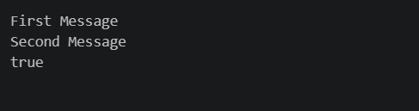

Exercise 2: Implementing the Factory Method Pattern
Scenario:
You are developing a document management system that needs to create different types of documents (e.g., Word, PDF, Excel). Use the Factory Method Pattern to achieve this.


